

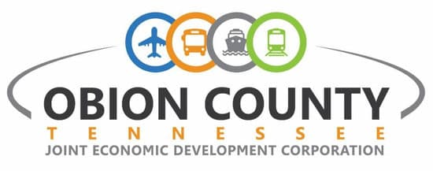

***A picture containing clipart

Description generated with very high confidence***



Welcome!

The [Chamber of Commerce](http://www.obioncounty.org/chamber/) and the [Obion County Industrial Development Council](http://obioncounty.org/edc/) are pleased that you are visiting our county. If you are considering a move here, or have recently settled in our area, you will find that Obion County is rich with economic opportunity. There is an excellent mix of industry – agriculture, environmental, healthcare, manufacturing, retail and an array of service-focused businesses. Our county has an excellent reputation for valuing education from pre-school through post-graduate; promoting the arts, visual and performing; and providing amenities desired in most communities. These amenities include many opportunities for outdoor recreation, air service, 150-bed hospital, a preserved and thriving downtown, a well-stocked new library, and nationally recognized science and history museum unlike any in the country. These are a few of the reasons our county was once selected as one of the top 20 rural towns in America and is a Tennessee [Three Star Community](http://www.tn.gov/ecd/CD_three_star.html).

If you have recently moved to Obion County, best wishes for your family and your new home. Moving to a new city and home is exciting, and with careful planning and attention, your move can be safe and stress-free. Included in this packet is contact information for area utility companies, government, educational, health care agencies and other services that will help ease your transition.

You will soon find we have excellent school systems, unique for the exceptional learning opportunities provided for students of all ages and ranking within the state school system. We encourage you to schedule a visit with both Union City’s and Obion County school systems to determine the school that would best meet your needs. Their websites are: [www.union-city-hs.obion.k12.tn.us](http://www.union-city-hs.obion.k12.tn.us) and [www.obioncountyschools.com](http://www.obioncountyschools.com). If you have additional questions, or would like to schedule a school visit, you may contact the Union City Board of Education office at (731) 885-3922, or the Obion County School System office at (731) 885-9743.

Whatever your purpose for visiting Obion County, home of Davy Crockett, Reelfoot Lake and Discovery Park of America, we hope this information packet will help you understand why so many choose to call Obion County home. If you should need further assistance, please do not hesitate to give us a call at (731) 885-0211.

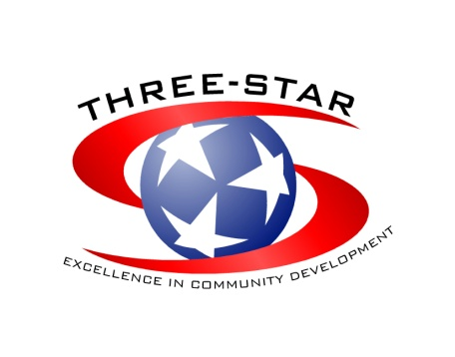

*214 East Church Street ● Union City, TN 38261 ● (731) 885-0211 ● Fax: (731) 885-7155 ● www.obioncounty.org*

*Northwest Tennessee Regional Trade Center*

**Table of Contents**

Important contacts 4

Where is Obion County?................................................................................................................................................6

Obion County Communities 7

Hornbeak, Tennessee 7

Kenton, Tennessee 7

Obion, Tennessee 9

Rives, Tennessee 9

Samburg, Tennessee 10

South Fulton, Tennessee……………………………………………………………………………………………………………………………………………………..9

Troy, Tennessee 11

Union City, Tennessee 12

Woodland Mills, Tennessee 15

Living Conditions 16

Climate 16

Religion 16

Cost of Living 16

Housing 16

Housing Contacts 17

Education and Training 18

Daycares & Preschools 18

Elementary & Secondary School System 18

Higher Education………………………………………………………………………………………………………………………………………………………………20

Other Education/Training Facilities 21

Medical and Health Care 22

Baptist Memorial Hospital 22

Nursing Homes & Assisted Living Centers 23

Other Healthcare 23

ThingsTo Do 24

Cultural Activities 24

Historic Sites/Museums 24

Discovery Park of America 25

Shopping 26

Fairs & Festivals………………………………………………………………………………………………………………………………………………………………..27

Outdoor Recreation 28

Restaurants 31

Fast Food Restaurants 31

Chain and Local Restaurants 31

Facilities………………………………………………………………………………………………………………………………………………………………………32

Union City Lodging 32

Reelfoot Lake Lodging 33

Clubs and ORganizations 34

Important Contacts

|  |  |  |  |
| --- | --- | --- | --- |
| **Town:** | Hornbeak | **Town:** | South Fulton |
| **Official** | Mayor Dennis Dozier | **Official** | Mayor David Lamb |
| **Address** | PO Box 265 | **Address** | 700 Milton Counce Dr. |
| **City, State, Zip** | Hornbeak, TN 38232 | **City, State, Zip** | South Fulton, TN 38257 |
| **City Hall** | (731) 538-9626 | **City Hall** | (731) 479-2151 |
| **Post Office** | (731) 538-2501 | **Post Office** | (270) 472-1836 |
|  |  | **Chamber** | (731) 479-7029 |
| **Town:** | Kenton | **Police** | (731) 479-1311 |
| **Official** | Mayor Danny Jowers | **Fire** | (731) 479-0213 |
| **Address** | 108 N Poplar |  |  |
| **City, State, Zip** | Kenton, TN 38233 | **Town:** | Troy |
| **City Hall** | (731) 749-5767 | **Official** | Mayor Deanna Chappell |
| **Post Office** | (731) 749-5212 | **Address** | PO Box 246 |
| **Utility** | (731) 749-0298 | **City, State, Zip** | Troy, TN 38260 |
| **Police** | (731) 749-5479 | **City Hall** | (731) 536-4745 |
| **Fire** | (731) 749-5800 | **Post Office** | (731) 536-4534 |
|  |  | **Police** | (731) 536-4342 |
| **Town:** | Obion | **Fire** | (731) 536-6397 |
| **Official** | Mayor Rodney Underwood |  |  |
| **Address** | PO Box 547 | **Town:** | Union City |
| **City, State, Zip** | Obion, TN 38240 | **Official** | Mayor Terry Hailey |
| **City Hall** | (731) 536-6242 | **Address** | PO Box 9 |
| **Post Office** | (731) 536-5531 | **City, State, Zip** | Union City, TN 38281 |
| **Police** | (731) 536-6244 | **City Hall** | (731) 885-1341 |
| **Fire** | (731) 536-5537 | **Post Office** | (731) 885-9711 |
|  |  | **Police** | (731) 885-1515 |
| **Town:** | Rives | **Fire** | (731) 885-4851 |
| **Official** | Mayor Stan Powell |  |  |
| **Address** | PO Box 179 | **Town:** | Woodland Mills |
| **City, State, Zip** | Rives, TN 38253 | **Official** | Mayor Wade Carrington |
| **City Hall** | (731) 536-5689 | **Address** | PO Box 153 |
| **Post Office** | (731) 536-5790 | **City, State, Zip** | Woodland Mills, TN 38271 |
| **Fire** | (731) 536-6321 | **City Hall** | (731) 885-8754 |
|  |  | **Post Office** | (731) 885-3970 |
| **Town:** | Samburg |  |  |
| **Official** | Mayor John Glessner | **County:** | Obion County |
| **Address** | PO Box 238 | **Official** | Mayor Benny McGuire |
| **City, State, Zip** | Samburg, TN 38254 | **Address** | PO Box 236 |
| **City Hall** | (731) 538-3235 | **City, State, Zip** | Union City, TN 38281 |
| **Post Office** | (731) 538-2242 | **Phone** | (731) 885-9611 |
| **Utility** | (731) 538-9702 | **Post Office** | (731) 885-3970 |
| **Fire** | (731) 538-2747 |  |  |
|  |  | **State and County Officials:** |  |
| **United States Officials*:*** |  | Bill Haslam, Governor | (615) 741-2001 |
| Lamar Alexander, U.S. Senate | (202) 224-4944 | Andy Holt, TN Senate Rep | (615) 741-7847 |
| Bob Corker, U.S. Senate | (202) 224-3344 | Bill Sanderson, TN State Rep | (615) 741-0718 |
| David Kustoff, U.S. Congress | (731) 412-1043 | John, Stevens, TN Senator | (615) 741-4576 |

Important Contacts

|  |  |  |  |
| --- | --- | --- | --- |
| **Other Offices** |  | **Banks** |  |
| 911 Office | 885-3316 | Commercial Bank & Trust | (731) 884-4255 |
| Ag. Extension Service | 885-3742 | First Citizens National Bank | (731) 885-2300 |
| Airport | 885-1221 | Simmons Bank | (731) 885-7090 |
| Assessor | 885-2931 | Reelfoot Bank | (731) 885-1010 |
| Board of Education | 885-9743 | Regions Bank | (800) 734-4667 |
| Child Support | 886-4520 |  |  |
| Circuit Court Clerk | 885-1372 | **Utilities** |  |
| Clerk & Master | 885-2562 | **Electric Service** |  |
| County Attorney | 885-1482 | Outside Union City: |  |
| County Clerk | 885-3831 | Gibson Electric Membership Corp. | (731) 536-5920 |
| District Attorney | 884-2610 | Inside Union City: |  |
| Driver's License | 884-2133 | Union City Electric System | (731) 885-9212 |
| Drug Court | 885-3411 |  |  |
| Drug Task Force | 884-2610 | **Natural Gas & Propane** |  |
| Election Office | 885-1901 | Gas | (888) 286-6700 |
| EMA Director | 599-4347 | Obion County Propane Gas, Inc. | (731) 885-2499 |
| Employment Security-Job Services | (731) 884-2621 | Suburban Propane | (731) 885-0580 |
| Fair | 446-6795 |  |  |
| General Sessions Office | 885-1811 | **Refuse/Waste** |  |
| Health Dept. | 885-8722 | Red River Waste Solutions | (731) 884-2860 |
| Highway Dept. | 885-5960 | Republic Services | (731) 885-5528 |
| Jail | 885-0277 |  |  |
| Juvenile | 885-4550 | **Telephone Service** |  |
| Landfill | 885-1941 | AT&T Telephone Company | (888) 757-6500 |
| Library | 885-7000 | Cinergy Communications | (800) 599-7000 |
| Local Government | (800) 737-1826 |  |  |
| Nursing Home | 885-9065 | **Water & Sewer** |  |
| OC Chamber of Commerce | 885-0211 | Hornbeak |  |
| Purchasing | 885-8580 | Water/Sewer/Gas | (731) 538-9626 |
| Register of Deeds | 885-9351 | Garbage | (731) 885-5528 |
| Rescue Squad | 885-6656 | Kenton | (731) 749-0298 |
| Section 8 Housing (Jackson) | (731) 410-2270 | Obion | (731) 796-1242 |
| Senior Citizens Center | 885-1246 | Rives | (731) 536-5689 |
| Sheriff ‘s Office | 885-5832 | Samburg |  |
| Solid Waste | 885-8109 | Water/Sewer/Gas | (731) 538-9702 |
| Trustee Office | 885-0951 | Garbage | (731) 885-5528 |
| Union City Animal Control | 885-7011 | South Fulton | (731) 479-2242 |
| UC Insurance | 885-5453 | Troy | (731) 536-4745 |
| UC Parks & Rec. | 885-0354 | Union City |  |
| Veteran's Service | 885-2781 | Water/Sewer | (731) 885-1341 |
|  |  | Garbage | (731) 885-1341 |
| **Newspaper** |  | Woodland Mills | (731) 885-8754 |
| The Daily Messenger | (731) 885-0744 |  |  |
|  |  | **Development Districts** |  |
| **Cable TV** |  | Northwest Tennessee | (731) 587-4213 |
| Charter Communications | (855) 757-7328 | Memphis Area Association | (901) 729-2871 |
|  |  | Southwest Tennessee | (731) 668-7112 |
| **Internet** | (731) 885-4772 | Greater Nashville | (615) 862-8828 |
| BellSouth | (855) 757-7328 | South Central Tennessee | (931) 379-2929 |
| Charter Pipeline | (731) 884-0203 | Upper Cumberland | (931) 432-4111 |
| Computers Direct | (731) 885-4000 | Southeast Tennessee | (423) 266-5781 |
| Ken-Tenn Wireless |  | East Tennessee | (865) 273-6003 |
|  |  | First Tennessee | (423) 928-0224 |

\**In some unincorporated areas of Obion County, natural gas is unavailable. Propane gas may be obtained for immediate delivery by calling any one of the following propane gas companies located in Union City, which serve Obion County:*

Where is Obion County?

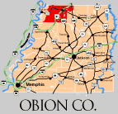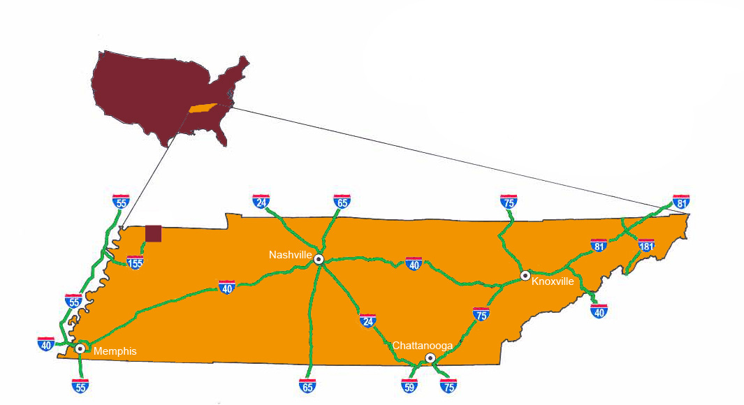

Obion County Communities

Hornbeak, Tennessee

Nestled in the rolling hills of western Obion County, just a few miles west of Troy and a short drive from scenic Reelfoot Lake sits the town of Hornbeak. For many years, this quaint little town was known as Wilsonville. Incorporated in 1916, the town's name was later changed to Hornbeak after the proprietor of the town's general store, Frank Hornbeak.

Mayor Dozier has great plans for Hornbeak including a new tag line for the town – Gateway to Reelfoot Lake. Recent developments include a new walking trail at Hornbeak’s City Park found on the northeast side of the town. The park features baseball, basketball and tennis courts, a picnic pavilion and a new playground. Flippens Peach Orchard is also located here and is quite a pretty view when all the blooms are out in spring.

Plans exist to build a new, larger fire station and city hall office. The Hornbeak fire department and first responders service is funded by subscription and serves Hornbeak and the surrounding area. Black Oak Elementary School (grades K-8) is in the Obion County School System and was built in the late 80s.

Newcomers and residents alike will say that Hornbeak is like Mayberry with a closeness that you do not find in larger size towns. You are invited to stop by the city hall and get to know the friendly staff. Be sure and inquire about their activities for the year.

Kenton, Tennessee

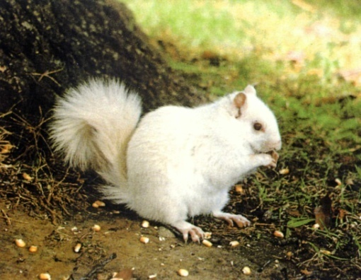

Kenton, named after Simon Kenton, a frontiersman, Indian fighter, surveyor, and an intimate friend of Daniel Boone, is a bedroom community of 1,308 located at the heart of the quad-county area. Approximately 15 minutes from four county seats, on Highway 45 West and Highway 89, Kenton resides in two counties (Obion & Gibson Counties) and is located 45 miles north of Jackson, Tennessee, 75 miles southwest of Kentucky Lake, 35 miles southeast of Reelfoot Lake and 5 miles from the Obion River bottom and Half Moon Lake.

The city of Kenton’s City Hall is centrally located on Highway 45 West. A police department with five full-time and three part-time policemen and a volunteer fire department serves the city. Kenton Utilities serves the community with water and sewer. The city also has a top-notch street department.

The new Kenton School opened its doors in the fall of 2002. The new 20,000 square foot facility offers large classrooms, a state of the art cafeteria, library, a large common/meeting area, administrative area, and a deluxe playground center.

Kenton is very unique as it is the home of the largest concentration of white squirrels in the nation. No one knows for sure where the white squirrels came from. The legend says that a traveling band of gypsies stopped outside of Kenton and asked a farmer to stay on his land for the night. The farmer welcomed the band. As a way of payment for the farmer's generosity, the gypsies gave the farmer a matched pair of white squirrels. After the band had left, the farmer released the squirrels in the towering pecan trees on his property. The squirrels multiplied and spread over the town. The city adopted the furry creatures and enacted laws to protect them. Those laws remain on the books to this day.

Many local residents feed and care for the squirrels. The new white squirrel sanctuary has many feeders and breeding boxes among the 50 species of trees. The best time to view the squirrels is during the early morning or late afternoon hours since the squirrels take refuge in the treetops during the heat of the day.

The people of Kenton are a close-knit community, and show their pride for the community with the White Squirrel Festival featuring a parade, street dance, and fireworks display each July 4th. Simmons Bank operates in Kenton. Other major businesses are Kenton Chevrolet, Food-Rite, Dollar General, Kenton Drug and Gift Shop, and White Squirrel Winery. Kenton welcomes newcomers! The City Hall is located at 108 North Poplar and is open Monday through Saturday

Obion, Tennessee

Located on Highway 183, east of highway 51, only 16 miles from the famous Reelfoot Lake sits the town of Obion, Tennessee. The Illinois Central Railroad runs through the town and Obion River/Gooch's Hunting & Fishing Reserve borders the town to the south.

Obion proudly provides its residents a typical small town environment, a haven for retirement, and a slow leisurely lifestyle. Tradition plays an important role in the lives of the townspeople, the majority of whom are over fifty. Obion also proudly offers an abundant water supply to its farmers and industries.

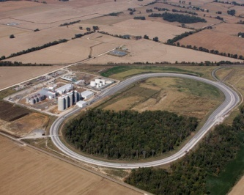 Obion's principal crops are wheat, cotton, corn and soybeans. In the spring and fall, farm trucks can be seen moving through town as they journey to the Obion Grain Company. It is home to an ethanol facility, Green Plains Obion. Reelfoot Metal is also located in Obion, fulfilling all your metal roofing or other project needs.

Rives, Tennessee

 Located just south of Union City, Rives was originally known as Troy Station. Settlers from South Carolina first came to the area in the 1820s and by the 1850s the town was flourishing because of the Mobile and Ohio Railroad. Rives has a rich railroad history and at one time the town had several hotels to serve the passenger trains traveling through the area.

Today when you drive through Rives you will experience first hand small southern town charm. The Obion River runs through part of the county, and is known as a mixture of bottomland hardwood forest and cropland for waterfowl management. Some of the more common wildlife to spot include Wild Turkey, White-tailed Deer, and in winter, waterfowl abound. Edge species, such as Indigo Bunting, are common in summer in addition to resident birds.

Samburg, Tennessee

Located only 23 miles from Union City lies the town of Samburg, where you can view the beauty of the Bald Cypress Trees and the unique Reelfoot Lake, created during the earthquakes of 1811 and 1812. Situated on the southern shore of the lake, Samburg thrives as a tourist destination year-round. The town attracts thousands of visitors for fishing trips on Reelfoot Lake during the spring and summer. Waterfowl hunters and bird watchers flock to Samburg in the fall and winter. The town offers visitors many options for motels and cabins to rent by the day or week, or tent and RV camping. Local businesses include the Blue Bank Resort, Pizza to Go, Walton’s Kwik Mart, and Moore’s One-Stop.

Residents can enjoy living in a close-knit community. Black Oak Elementary in Hornbeak serves as the elementary school for Samburg. The high school for residents is the Obion County Central High School in Troy. Both offer bus service. Samburg recently built a city hall that includes a visitor’s center and civic center. The town boasts two parks, Samburg City Park on North Reelfoot Avenue, and Spicer Park on Lakeview Drive. The City Park has a playground, baseball field and picnic pavilion. Spicer Park has an excellent view of the lake and is often selected as a wedding site by local residents. Samburg also hosts several annual events including Fun Day in the Park at City Park, an archery shoot, the Waterfowl Festival at Eagle’s Nest Hotel, and the Christmas Parade in December.

**South Fulton, Tennessee**

In the far northeast corner of Obion County and bordering its Twin City - Fulton, Kentucky - rests the town of South Fulton. The South Fulton Municipal Complex serves as the hub of all city operations, and houses the City Hall, Police Department, Fire Department, Public Works, the Twin Cities Railroad Museum and the Twin Cities Chamber of Commerce office. South Fulton Elementary and South Fulton Middle/High School are part of the Obion County school system. The town boasts a variety of recreational facilities and several major industries including the Tyson Foods feed mill.

The town also hosts an annual community Egg Hunt in the spring and a yearly Bar-B-Que Competition. The City of South Fulton also co-sponsors the annual Twin Cities Banana Festival. In 2016, the Unity Park Amphitheater in South Fulton was the home for the first KYTN Country Music Festival, which is well on its way towards becoming an annual event.

Troy, Tennessee

 The town of Troy, *“Where Nice People Live,”* is located south of Union City, in the heart of Obion County at the intersection of Hwy. 51 and 21. This mostly farming community of 1,285 plus residents is surrounded with rolling hills, rows of corn and soybean crops and beautiful pasture. Historically, the town of Troy has the distinction of being the first incorporated town of Obion County (1834). The town’s design was established with the help of Davy Crockett, the famous frontiersman who lived, hunted and explored the area. Originally, Troy served as the county seat until July 1890. Once located on the grounds of today’s City Park, the courthouse burned in 1889, at which time the citizens of Obion County voted to not rebuild and move the county seat to Union City.

Troy has a beautiful town square now occupied by a well-maintained park with potential for new enterprise to develop in old historic buildings. Over 40 businesses can be found in Troy ranging from agriculture support services, automotive repair, a well maintained 18 hole golf course and adjoining residential building lots, restaurants, E.W James Grocery Store, and many service industries – salons, pharmacy and walk-in clinic to name a few. Two thriving sawmills located in the heart of the town are major employers for the area. The Troy Industrial Park located on U.S. Hwy. 51 has all utilities located on-site.

Troy has a beautiful town square now occupied by a well-maintained park with potential for new enterprise to develop in old historic buildings. Over 40 businesses can be found in Troy ranging from agriculture support services, automotive repair, a well maintained 18 hole golf course under new ownership with adjoining residential building lots, restaurants, E.W James Grocery Store, special events center (Moffett Center), subdivisions and apartments, and many service industries – salons, pharmacy and walk-in clinic to name a few. Two thriving sawmills are located in the heart of the town are major employers for the area.

The citizens of Troy take pride in their community. The town contains two well-maintained parks – City and Troy, municipal complex, conference/recreational center, senior citizens building, fire and police service, post office, sports activities for all ages, a wide selection of church denominations, community events such as the Pecan Festival and more. The Pecan Festival features a classic car show, free white beans and cornbread, free butter pecan ice cream, and other fun activities. Troy Park, accessible by walking from downtown, is beautifully landscaped and provides a paved walking track, tennis courts, ball fields, playground area and basketball court.

The town also serves as the setting for Obion County Central High School, one of three high schools located in the county*.* Obion County Central, Home of the Rebels, has over 950 students. Understanding that every student is unique in their educational needs this school offers a selection of paths toward academic excellence: The University Path, Technical Path, or Dual (a combination of both University and Technical). Hillcrest Elementary is also located in Troy and provides education for grades Pre-K through 8th grade.

The town of Troy invites you to visit. The City Hall is open Monday-Friday from 9 until 5.

Union City, Tennessee

Union City is the largest city (population 10,590) and the county seat of Obion County. Union City has the distinction of being the Regional Trade Center for northwest Tennessee and southwest Kentucky and is designated a “micropolitan area” by the U.S. census. The town is centrally located in reference to several major cities – St. Louis, Louisville, and Little Rock, and is only 140 miles north of Memphis and 175 miles west of Nashville. Union City is unique in that it is the crossroads or “union” of two major railways. At the time of development, these railways were the *Gulf, Mobile and Ohio* that ran south to north from Mobile, AL to Chicago, IL and the Nashville, Chattanooga & St. Louis that ran east to west. The railways were designed in the early 1850s to intersect in Union City on Church Street. In 1852, General G.W. Gibbs employed a civil engineer from Richmond, Virginia to survey for a location for a rail line that would link Nashville, TN to Hickman, KY. It was here that Gibbs provided the town’s namesake by writing "Union City" with red chalk on a white oak tree.

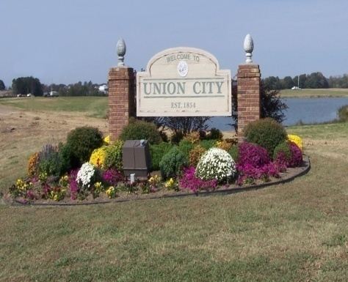

Union City has a rich heritage and an exciting future. Once the stomping grounds of Davy Crockett at a time when the city was known as The Great Malarial Swamp, Union City, laid claim to being the vicinity where Crockett killed 105 bears in one day. Its subsequent growth was based on its proximity to the railroad, the rich timber and farmland, central geographic location, and a community known for a strong work ethic and appreciation for education.

Today Union City has a robust and diverse business community. Major businesses include Baptist Memorial Hospital, Tyson Foods, Made in America Seating, The Kohler Company, Titan Tires, Greenfield Products, Simmons Bank and many agriculture support businesses that serve a county that is the largest corn producer in Tennessee. Numerous non-profits, philanthropists and community volunteers are also active in the community to ensure a higher quality of life for its citizens.

In terms of commerce, Union City is served by four modes of transport:

* + **Rail** – Directly served by the Canadian National (CN) Railroad, the only rail carrier in the U.S. that provides coast-to-coast service from the Atlantic to the Pacific as well as Canada to the Gulf Coast.
  + **Wate**r – The Port of Cates Landing Deepwater/Slackwater Port located in neighboring Lake County, approximately 20 miles west of Union City.
* **Air** – The Everett-Stewart Regional Airport on Airport Circle Road just south of State Highway 431 (Old Highway 22) approximately 4 miles southeast of Union City and has an existing runway and parallel taxiway of 6,500 feet.  Has an ILS (Instrument Landing System), and the capability to serve 67% of the nation’s most popular corporate business jet aircraft operating at maximum capacity.  Everett-Stewart Regional Airport is becoming a general aviation airport facility that is required for an entire region, not just a community and is on its way to becoming a “World Class” General Aviation Airport.
  + **Highway** – Presently served by U.S. 51 connecting to the Kentucky Interstate System and I-55 and SR 22 providing direct access to I-40 near Jackson, Tennessee. SR 45 is scheduled to be upgraded to four-lane and will provide a direct link to I-40 in Jackson. In addition to these improvements Interstate 69 connecting Canada to Mexico is currently under construction.

The George C. Cloys Industrial Park offers over 50 acres of prime industrial property with all utilities on-site. Adjacent to US Hwy. 51, the park is served by the Illinois Central Railroad and is within 10 miles of Hickman, KY. Also nearby is the Northwest Tennessee Regional Industrial Center located on 548 acres at the intersection of U.S. Hwy. 51 and State Route 21. Veteran’s Park is located here.

Union City honors its past and embraces the future. In the heart of Union City, you will find the renovated Capitol Theatre and Church Street Railroad Depot that is now used as the home for the Chamber of Commerce. With multiple parks in our community – Kiwanis, Veterans, Graham and Reelfoot Pond – there are many opportunities for outside activity: baseball, tennis, basketball, football, fishing, running or walking and more.

The Obion County Public Library is also located in Union City. This new library has one of the largest collection of books for west Tennessee over 70,000 housed in a new 30,000 sq. ft. facility on four acres.

Discovery Park of America, a most unique museum and interactive educational venue, opened in November of 2013. It is a multi-faceted educational complex with a focus on nine different galleries covering nature, science, technology, history, and art spread over a 50-acre site.

Other unique businesses that include Dixie Gun Works, host to one of the finest collections of old vehicles and antique guns with over 1500 guns and 31 antique vehicles. If you are an avid motorcycle enthusiast, be sure to visit Abernathy’s – one of the more successful motorcycle dealerships in the U.S. While downtown, enjoy numerous restaurants, antique shops, specialty shops and clothing stores, or the farmer’s market that is open most Saturday’s. In addition to the downtown area, Union City has many retail and business centers, restaurants, hotels and other businesses that provide a base for future economic growth.

Regardless your area of interest – business, arts, science, sports, shopping or entertainment, we know you will find Union City is an unforgettable destination.

Woodland Mills, Tennessee

Incorporated in 1968, the pleasant little town of Woodland Mills is located only a few miles west of Union City in Obion County, and is practically a bedroom community to the county seat. The town first began as a settlement with the construction of the Nashville & Northwestern Railroad that was constructed soon after the Civil War during the Reconstruction. Woodland Mills is believed to have gotten its name from the fact that when it was settled it was primarily a wooded area and the earlier industries were mills.

Conveniently located on Highway 5 (Union City /Hickman Highway) and near Interstate I-69, which is currently under construction and will connect Canada to Mexico, Woodland Mills is poised for new business and tourism. Currently, the town boasts a city hall, post office, a community center, tennis courts, a walking track and several ball fields in addition to several small businesses. Considered an agricultural community, many residents farm corn, winter wheat and soybeans in the area. With a population of less than 400, Woodland Mills is served by Lake Road School and Obion County Central High School in nearby Troy.

Living Conditions

|  |  |  |
| --- | --- | --- |
| **Climate** | **Obion, TN** | **United States** |
| [Rainfall (in.)](javascript:alert(%22The%20annual%20rainfall%20in%20inches.%20Updated:06/12%22);) | **51** | **39** |
| [Snowfall (in.)](javascript:alert(%22The%20annual%20snowfall%20in%20inches.%20Updated:06/12%22);) | **5** | **26** |
| [Precipitation Days](javascript:alert(%22The%20annual%20number%20of%20days%20with%20measurable%20precipitation%20(over%20.01%20inch).%20Updated:06/12%22);) | **77** | **102** |
| [Sunny Days](javascript:alert(%22The%20average%20number%20of%20days%20per%20year%20that%20are%20predominantly%20sunny.%20Updated:06/12%22);) | **211** | **205** |
| [Avg. July High](javascript:alert(%22The%20average%20daily%20high%20temperature%20for%20the%20month%20of%20July,%20in%20degrees%20Fahrenheit.%20Updated:06/12%22);) | **89.3** | **86.1** |
| [Avg. Jan. Low](javascript:alert(%22The%20average%20daily%20low%20temperature%20for%20the%20month%20of%20January,%20in%20degrees%20Fahrenheit.%20Updated:06/12%22);) | **26.1** | **22.6** |
| [Comfort Index (higher=better)](javascript:alert(%22...Higher%20values%20indicate%20a%20more%20confortable%20climate.%20%20The%20Comfort%20Index%20measure%20recognizes%20that%20humidity%20by%20itself%20isn't%20the%20problem.%20%20(Have%20you%20noticed%20nobody%20ever%20complains%20about%20the%20weather%20being%20'cold%20and%20humid?)%20%20It's%20in%20the%20summertime%20that%20we%20notice%20the%20humidity%20the%20most,%20when%20it's%20hot%20and%20muggy.%20%20Our%20Comfort%20Index%20uses%20a%20combination%20of%20afternoon%20summer%20temperature%20and%20humidity%20to%20closely%20predict%20the%20effect%20that%20the%20humidity%20will%20have%20on%20people.%20Updated:06/12%22);) | **52** | **54** |
| [UV Index](javascript:alert(%22The%20UV%20Index%20is%20a%20measure%20of%20an%20area's%20exposure%20to%20the%20sun's%20ultraviolet%20rays.%20This%20is%20most%20often%20a%20combination%20of%20sunny%20weather,%20altitude,%20and%20latitude.%20Updated:06/12%22);) | **4.7** | **4.3** |
| [Elevation ft.](javascript:alert(%22The%20elevation%20or%20altitude,%20in%20feet.%20Updated:06/12%22);) | **353** | **1,443** |

Climate

[*http://www.bestplaces.net/climate/county/tennessee/obion*](http://www.bestplaces.net/climate/county/tennessee/obion)

Religion

All major denominations are represented within Obion County: Apostolic, Assembly of God, Baptist, Catholic, Church of Christ, Church of God, United Methodist, Pentecostal, Presbyterian, etc.

Cost of Living

March 2016 cost of living index in Obion County: 79.6 (low, U.S. average is 100)

[*http://www.city-data.com/county/Obion_County-TN.html*](http://www.city-data.com/county/Obion_County-TN.html)

|  |  |  |  |  |  |  |  |
| --- | --- | --- | --- | --- | --- | --- | --- |
|  | Cost of Living Index | Grocery | Housing | Utilities | Transportation | Healthcare | Misc. Goods & Services |
| Obion County, TN | 90.3 | 100.8 | 75.2 | 102.0 | 96.3 | 87.3 | 94.3 |
| Springdale, AR | 90.5 | 98.4 | 75.2 | 85.5 | 64.3 | 81.8 | 100.8 |
| Jackson, TN | 90.2 | 100.4 | 84.5 | 82.1 | 91.5 | 80.0 | 94.0 |
| Memphis, TN | 98.3 | 105.8 | 90.6 | 92.2 | 109.3 | 99.4 | 100.0 |
| Paducah, KY | 90.7 | 95.5 | 89.7 | 86.7 | 85.0 | 84.0 | 93.3 |

Housing

* **Prices (new)** — Ranges from an average of $75,000 to $160,000 (3 bedroom home, depending on location, size, design and the selection of materials)
* **Prices (older)** — Ranges from an average of $40,000 to $80,000
* **Mortgage Payment** – Average mortgage payment annually is $5117 or $426 monthly (Based on 30 year home loan.)
* **Appreciation** – Average appreciation is 38%
* **Rental Housing/Apartment** - Ranges from an average of $300 to $500 per month

Housing Contacts

|  |  |
| --- | --- |
|  |  |

**Apartment Properties**

**Crestwood Apartments**

West Washington Avenue

Union City, TN 38261

(731) 885-7691

**Davy Crockett Senior Center**

515 S First Street

Union City, TN 38261

(731) 885-9431

*\*Section 8 Housing (elderly)*

**Eaglewood Apartments**

Eaglewood Drive (Kentucky)

(731) 885-7691

**East Gate Village Apartments**

515 Nash Street

Union City, TN 38261

(731) 885-3934

*\*Section 8 Housing (family)*

**East Towne Apartments**

Hillsboro Street, UC

Union City, TN 38261

(731) 885-5971

**Evergreen Apartments**

731 S Sunswept Drive

Union City, TN 38261

(731) 587-3186

*\*Section 8 Housing (disabled)*

**Hillwood Manor Apartments**

1732 Stone Street

Union City, TN 38261

(731) 885-0667

**Imperial Apartments**

High School Drive

Union City, TN 38261

(731) 885-9549

**Norwood Apartments**

Norwood Drive

Union City TN, 38261

(731) 885-7691

**Parkview Manor Apartments**

714 Sunswept Drive

Union City, TN 38261

(731) 885-3485

*\*Section 8,Income based*

**Plantation East Apartments**

Sunswept Drive

Union City, TN 38261

(731) 885-7691

**Apartment Properties**

**Ware Park Apartments**

1464 E. Cheatham Street

Union City, TN 38261

(731) 630-4466

*\*Income Based*

**Reelfoot Apartments**

Hillsboro Street

Union City, TN 38261

(731) 885-2942

**Summer Street Apartments**

Summer Street

Union City, TN 38261

(731) 885-7691

**Union City Apartments**

Lynn Street

Union City, TN 38261

(731) 885-8142

*\*Section 8 Housing (family)*

**Union City Housing Authority**

1409 E Main Street

Union City, TN 38261

(731) 885-1971

**Real Estate Agencies**

**Alexander Auction and Real Estate**

(800) 748-8567

**Carpenter Real Estate Company**

(731) 885-3981

**Century 21 Golden Service Realty**

(731) 885-8000

**Cook Realty**

(731) 885-5400

**Fuller Partners Real Estate**

(731) 885-8041

**Re/Max United**

(731) 885-1100

**Shea Riley Realtors and Appraisers**

(731) 885-0500

**Rental Contacts**

**Ralph Adams**

(731) 885-2100

**Jeff Allen**

(731) 504-3600

**John Asbille**

(731) 538-9566

**Wayne Barker**

(731) 885-8032

*\*Commercial Properties Only*

**Britt Barkley**

(731) 885-4650

**Steve Goodrich**

(731) 885-2100

**Ed Griffin**

(731) 885-2666

**Boyd Hill**

(731) 885-9668

**David Darnall**

(731) 885-5874

**Bill Quinton**

(731) 446-3600

**Shea Riley**

(731) 885-0500; (731) 796-3052

Donna Riley: (731) 796-7231

**Randy Roney**

(731) 885-2333

**Allen Searcy**

(731) 885-7691

\**Ask for Marlayna*

**Joe Sergerson**

(731) 335-1302; (731) 885-2386

\**After 5pm*

**GTIC Properties**

(731) 885-0667

Education and Training

Daycares & Preschools

The following is a list of licensed daycare and preschool centers in Obion County:

* **Children's Corner Day Care** *(731) 885-1992*
* **First Friends Preschool** *(731) 885-9813*
* **Kare Bear Daycare Center** *(731) 885-9211*
* **Kenton Head Start** *(731) 749-6435*
* **Little Lambs Day Care** *(731) 885-8650*
* **Miles Head Start** *(731) 885-1533*
* **Mrs. Lynn's Day Care** *(731) 479-3181*
* **The Pumpkin Patch Day Care** *(731) 884-1005*
* **Small World Child Care Inc.** *(731) 885-8870*
* **Pleasant Valley United Methodist** *(731) 885-5203* (Mother's Day Out Program)

Elementary & Secondary School System

Obion County School System

[www.obioncountyschools.com](http://www.obioncountyschools.com)

|  |  |  |
| --- | --- | --- |
| **School** | **Type** | **Contact** |
| **Black Oak Elementary** | Elementary | (731) 538-2271 |
| **Hillcrest Elementary** | Elementary | (731) 536-4222 |
| **Lake Road Elementary** | Elementary | (731) 885-5304 |
| **Ridgemont Elementary** | Elementary | (731) 536-5171 |
| **South Fulton Elementary** | Elementary | (731) 479-2304 |
| **South Fulton Middle School** | Middle School | (731) 479-1441 |
| **Obion County Central High School** | High School | (731) 536-4688 |
| **South Fulton High School** | High School | (731) 479-1441 |
| **Director of Schools** | Director | (731) 885-9743 |

* **Building Program** — Elementary schools and South Fulton Middle and High School were built during the '90s. Obion County High School was built in 2007.
* **Preschool Program** — Includes screening services, counseling for parents, and a home base program to help parents work with their children outside the school setting.
* **Elementary Schools** — Students have access to computers at each grade level and are proficient in their use before leaving middle school. The newly constructed schools are equipped with science labs, modern library facilities, music rooms and well-equipped classrooms for the best possible student instruction.
* **High School** — Offers the required State mandated curriculum as well as the Tennessee Honors Program and a more advanced Challenge curriculum for students wishing to take higher-level college prep courses in science and math.
* **Obion County Vocational Center** — The center provides classes that are designed to prepare students for post-secondary studies or to develop skills used by local industries. The vocational school operates a modern school where students are trained in the areas of auto mechanics, auto body, building trades, masonry, welding, machine shop, office, and aviation education.

|  |  |  |
| --- | --- | --- |
| **School** | **Type** | **Contact** |
| **Union City Elementary School** | Elementary | (731) 885-1632 |
| **Union City Middle School** | Middle School | (731) 885-2901 |
| **Union City High School** | High School | (731) 885-2373 |

### **Union City School System**

<http://www.tornadotouch.net/>

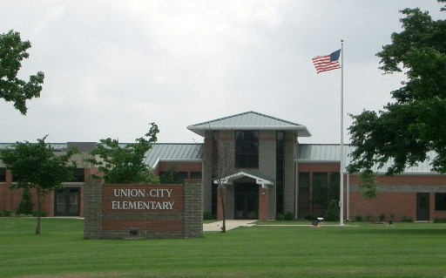

* **Elementary School** — Built in 2000, the school offers all the latest technology in teaching. Each grade is equipped with its own computer lab and designated playground. The school also contains a modern library facility, a gymnasium, and a recreational activities room all of which give students the best instruction possible.

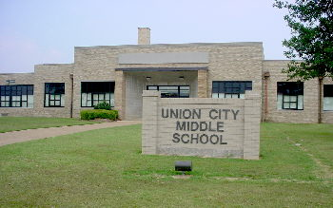

* **Middle School** — Consisting of seventh and eight grades, the Union City Middle School employs 26 certified personnel. The school has an active Junior Beta Club and a Top Ten Academic Recognition program designed to encourage academic excellence. The Southern Association of Colleges and Schools accredit the school.

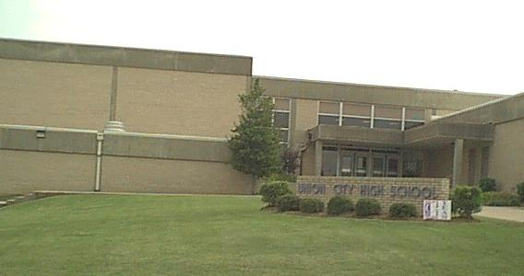

* **High School** — Consisting of grades 9 - 12, the curriculum consists of both academic and vocational courses. Approximately 70% of the graduates enter a post-graduate program. Union City High School employs 40 certified personnel and is accredited by the Southern Association of Colleges and Schools.
* **Extra-Curricular Activities** — The activities are an important part of the educational system. Union City students participate in a variety of activities ranging from team sports (football, basketball, track, tennis, golf, and baseball) to clubs (civic and academic).

Higher Education

Dyersburg State Community College

[](http://www.dscc.edu/)[www.dscc.edu](http://www.dscc.edu) (731) 286-3200

A comprehensive, two-year post-secondary institution offering programs in liberal arts, technical, professional, developmental, and enrichment programs, DSCC is a higher education institution of the State University and Community College System of Tennessee and is accredited by the Commission on Colleges of the Southern Association of Colleges and Schools to award the associate degree.

University of Tennessee at Martin

[www.utm.edu](http://www.utm.edu) (731) 881-7000

A four-year university offering Bachelor and Master degrees in more than 70 specialized fields through the Schools of Agriculture and Applied Sciences, Business and Global Affairs, Education, Health and Behavioral Sciences, Engineering and Natural Sciences, and Humanities and Fine Arts. UTM and its programs are accredited by several agencies and is the largest institution in the UT system outside a major urban area.

Obion County Industrial Training & Education Center of DSCC

(731) 884-0171

An industrial training center which utilizes a state-of-the-art facility to meet the demands of the area through quality education and training, the center's primary goal is to retain and promote economic development opportunities in Northwest Tennessee as well as to support local industries, provide support to employers in Northwest Tennessee, assist in recruiting new industries, and train new maintenance personnel in the latest technology. Whatever your training needs may be, the instruction delivered will have a positive effect on your business or industry.

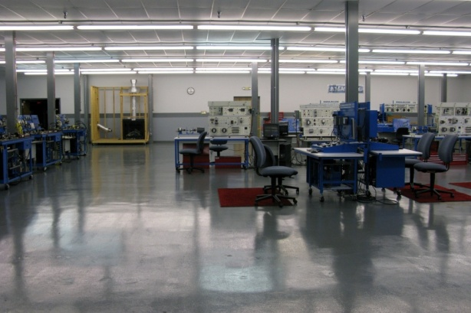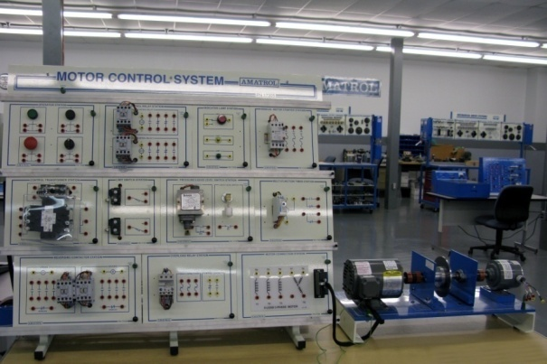

Tennessee College of Applied Technology

[www.tcatnewbern.edu](http://www.tcatnewbern.edu) (731) 627-2511

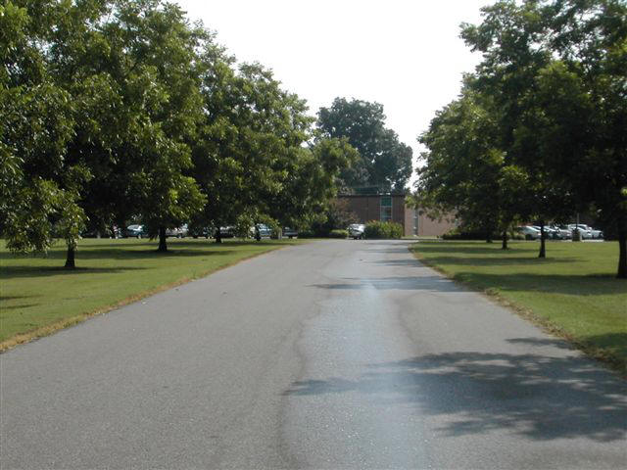The purpose of the State Area Vocational-Technical School at Newbern is to provide training in occupations designated by local businesses and industries as those needing a supply of skilled or trained employees. The school provides occupational training in the areas of automotive mechanics, electronics, drafting, machine shop, welding, air conditioning & refrigeration, industrial maintenance, business systems technology practical nursing and others.

Obion County Public Library

[www.oclibrary.org](http://www.oclibrary.org) (731) 885-7000

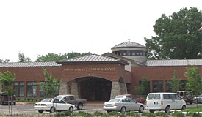The largest public collection in West Tennessee outside of Jackson and Memphis, the new 30,000 sq. ft. facility contains over 60,000 books, magazine, videos, etc. The library also features a Children’s' Room with a computer equipped with a variety of educational software, a Tennessee Room used for studying history and genealogy as well as microfilm and photocopy services, and public access computers available with Internet, research and word processing capabilities for adults. A walking track and amphitheatre in the back of the library offers a walking track area for exercise and benches for relaxation. Numerous programs for children and adults are offered throughout the year.

Boys & Girls Clubs of Northwest Tennessee

(731) 885-0883

The Boys & Girls Club of Northwest Tennessee offers programs to children ages 6 to 18. The programs address various topics such as adopting healthy attitudes, acquiring positive self-concepts, developing sound decision-making, maintaining responsibility, resisting drugs and alcohol, postponing sexual activity, considering careers, participating in the community, increasing behavioral and social skills, escalating academic skills, etc. The club also treats the children to events that include swimming, bowling, skating, sleepovers, reading adventures, camping, and "theme" weeks such as health and safety, the jungle, space, the beach, and more. From all the clubs activities, the members learn about respect for themselves and others, safety, importance of learning, and commitment to helping others in the community.

Medical and Health Care

Baptist Memorial Hospital

[www.baptistonline.org/locations/unioncity](http://www.baptistonline.org/locations/unioncity)~ (731) 885-2410

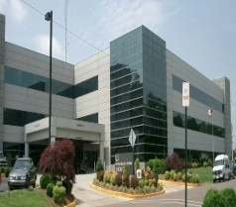

Baptist Memorial Hospital-Union City, formerly Obion County General Hospital, became part of the Baptist system in 1982 and is located in the northwest corner of Tennessee, just south of the Kentucky border.

In 1995, construction was completed on a new three-story, 85,000-square-foot patient tower. This construction added patient rooms and tripled the size of the emergency department.

BMH-Union City recognizes that the foundation for our facility is the teamwork of our employees, medical staff members, board of directors and hospital auxiliary members. We all work together to provide the very best patient service through a program called "Service First."

* **Awards -** Baptist Memorial Hospital-Union City recently was named a recipient of the 2017 QUEST award for High-Value Healthcare consistently providing outstanding patient care and setting a high standard in clinical excellence.
* **Beds –** 173 acute care beds, 14 beds for critical care and a 20-bed unit for adult psychiatric and substance abuse patients.
* **Cardiac** – The hospital has instituted a cardiac catherization service, utilizing a mobile lab for patients who meet certain protocols, allowing the procedures to be performed safely, quickly, and with minimal expense.
* **Services** –Home care and hospice, physical therapy, cancer treatment, a 24-hour emergency room, MRI testing, radiation oncology, ACR certified mammography unit, educational services, support groups, and special programs designed to promote and enhance healthy life-styles.
* **Staff** – Medical staff numbers over 100. Services provided at the local hospital include: family practice, general surgery, pediatrics, orthopedic surgery, radiology, and a wide variety of other specialties.

Nursing Homes & Assisted Living Centers

* **The Waters of Union City** – This skilled and intermediate 101-bed facility offers 24-hour nursing care, therapeutic diets, physical therapy, occupational therapy, and speech therapy. (731) 885-6400
* **Etheridge House/The Arbors** – This assisted care living facility has 24-hour personal assistance, medication supervision by a licensed D.O.N., home-style meals, housekeeping, and laundry. (731) 599-2925
* **Magnolia Place** – This facility is an assisted care living facility offering a full-time 24-hour nursing staff, medication management, home cooked meals, and assistance with daily living activities. (731) 885-8004
* **Obion County Nursing Home** – A country setting providing a clean, homey environment for 56 residents, a 24-hour licensed nurse, daily activities, home cooked meals, and a therapeutic diet. (731) 885-9065
* **Park Terrace Village** – Park Terrace Village offers an alternative to premature nursing home care. The facility offers a full-time nurse and activities director. (731) 479-1321
* **Union City Manor Nursing & Rehab Center** – Private pay and TennCare fund this 83-bed intermediate care facility. (731) 885-8095
* **Other Facilities** - *Life of Riley* in Troy, Tennessee, and *Ridgely Care and Rehabilitation Center*.

Other Healthcare

* **Home Health Care** – Obion County offers five home healthcare agencies that provide nursing care, multiple types of therapy, and management of diet, diabetes, and medication.
  + Parkway Regional Home Health (270) 472-0894
  + Baptist Home Care & Hospice (731) 884-8617
  + Extendicare of West Tennessee (731) 885-0866
  + Volunteer Home Care (731) 886-0305
  + Careall Home Care Services (731) 665-6633
* **Obion County Health Department** – Staff includes several nurses, aids, and clerks; environmentalists; a lay home visitor; a nutrition educator; a TIOP (Toward Improvement of Pregnancy); and a family planning official. (731) 885-8722
* **Pathways Counseling Center** – The center provides help to children struggling with peer pressure, individuals suffering from a mental illness, couples seeking counseling, and persons battling an addiction. Skilled professionals in the multi-disciplinary treatment team include: psychiatrists, licensed clinical social workers, psychiatric nurses, psychological examiners, licensed professional counselors, case managers, program technicians, psychologists, pharmacists, master’s level social workers, certified alcohol and other drugs of abuse counselors, prevention and intervention specialists, and crisis clinicians. (731) 885-9333
* **Northwest Regional Health Office** – Provides administrative support and technical assistance for rural West Tennessee health departments. There are twenty-one health service providers and staff at the office. Three direct services provided by the regional health office are x-ray screening for tuberculosis, pediatric clinic for Children’s Special Services clients, and dental services to children referred by the Obion County Health Department. (731) 423 - 6600

Things To Do

Cultural Activities

* **Community Concerts—** Community Concerts sponsors an annual series of concerts by nationally known groups and individuals. Past presentations include: The Glen Miller Orchestra, Floyd Cramer, the Mac Frampton Trio, and The Platters.
* 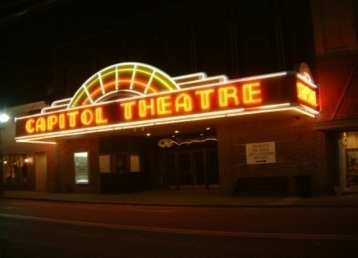**Masquerade Theatre —** The Masquerade Theatre, a local theater group, presents four or more high-quality productions annually. Past productions include: Grease, Oklahoma!, Oliver, The Sound of Music, Cats, The Wizard of Oz, Dearly Beloved and Steel Magnolias. Masquerade Theater recently acquired and renovated the historical Capitol Theater, whichis located on First Street in downtown Union City.

Historic Sites

* **Campground Cemetery —** This cemetery is the burial place of many county pioneers, located 3 miles south of Troy. Wilson Cabin (unmarked), where county organization took place, is 2 miles south of the cemetery.
* **Court Square, Troy —** Troy was the first town (1825) and original county seat (1825-1890) of Obion County. It was also the site of the first courthouse. Davy Crockett helped to design the town.
* **First Monument of Unknown Confederate Dead** – This monument was erected in 1869 to honor the unknown Confederates who died during the Civil War. It is listed on the National Register and the first monument ever erected by a group to honor the unknown Confederate dead.

**Museums**

* **Old Car Museum –** The Old Car Museum is a division of Dixie Gun Works, which supplies equipment for collectors of antique and replica muzzle-loading arms. The museum features antique automobiles, farm engines, antique car accessories, and an 1850 log gun shop. [www.dixiegunworks.com](http://www.dixiegunworks.com)

Discovery Park of America

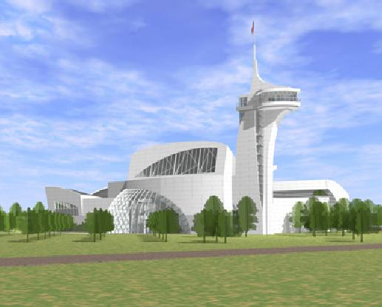Discovery Park of America is a 50-acre education and entertainment complex for adults and children. Discovery Center, the flagship building, has a distinctive design that is unique and futuristic in order to pique people’s curiosity to explore within. The white metal and glass structure has multiple roof levels with curving features instead of straight lines to make it more unusual. The three-level, 100,000 SF building features ten galleries with more than 70,000 SF of exhibits. The most prominent feature of the building is a 120-foot observation tower with a flagpole that stretches its height to almost 200 feet. The tower includes both indoor and outdoor observation areas and includes some glass floor panels. The observation room can accommodate gatherings of 70 people.

Discovery Park’s areas outside Discovery Center offer many varied and interesting opportunities to visitors. Whether touring the historic areas representing life many years ago or pausing in a beautiful garden or alongside a waterfall, visitors have many opportunities to relax, learn, and enjoy. More than 40 acres of beautiful outside experiences await visitors. A magnificent water feature flowing north to south allows visitors to enjoy the sights and sounds of flowing water. A hillside amphitheater and an expansive open lawn provide venues for concerts and outdoor events. Three different gardens are featured on the grounds: American, European, and Japanese. These beautiful settings invite visitors to enjoy a relaxing stroll among beautiful flowers, plants, and trees.

Discovery Park of America is a multi-million dollar educational venue that will enable visitors to understand and celebrate the culture, spirit and accomplishments of the human race in nature, science, art and history. The Robert E. and Jenny D. Kirkland Foundation is the principal benefactor of Discovery Park. The Kirkland’s vision for this venue is a place where children and adults can learn in an entertaining and pleasant environment.

**Cooperation and Involvement**

Discovery Park of America was a cooperative endeavor with broad participation by the citizens of Union City, as well as Obion and surrounding counties. Hundreds of dedicated volunteers planned each themed area of the venue. Local and state governments also took an active role in the museum’s development.

[www.discoveryparkofamerica.com](http://www.discoveryparkofamerica.com)

Shopping

Marketplace Shopping Center

Maurice’s, Hibbett’s Sporting Goods, VF Outlet, Goody’s, Shoe Shack, Bargain Hunt and various other shops and restaurants are located in this center on U.S. 51 South.

Court Square

A photography studio, restaurants, pharmacy, gift store, wedding chapel, and a discount store are just a sampling of the variety of shopping experiences you can find at the Court Square, located in downtown Troy.

Downtown

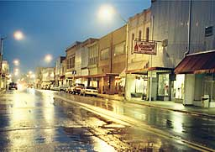

In the heart of each of our many communities lies a treasure trove of unique antique shops, fashions for men, women and children, florists, gift and specialty stores, as well as pharmacies, and appliance & furniture stores. Many of these shops are housed in historic buildings. Some date as far back to the late 1800’s and early 1900’s.

The Fashion Center

Located on East Reelfoot Avenue and Home Street, the center offers an excellent selection of men’s clothing at Five Seasons, in addition to a hair salon. Located immediately behind the center is a Fred’s store.

Shopping Center

Featuring Big Lots, Aaron’s, and Goodwill, the center is located in Union City at Reelfoot Avenue and South First Street.

Obion Square

The center, located In Union City on East Reelfoot Avenue, houses E.W. James Supermarket, Calla Lily Flower & Gift Shop, a pharmacy, a fitness center, and several restaurants including Don Sol and Snappy Tomato’s Pizza.

Reelfoot Shopping Center

Located at U.S. 45 West and Reelfoot Avenue in Union City, this large center includes a bridal boutique, an auto supply store, a Dollar General, and a consignment clothing store among other shops.

Village Plaza

Located on Broadway in South Fulton, this shopping center offers a variety of venues including a restaurant, gift store, drug store, and women’s exercise facility/spa.

**Fairs & Festivals**

|  |  |  |
| --- | --- | --- |
| **Month** | **Event** | **Contact** |
| February | Annual Eagle Festival | Reelfoot Tourism (731) 253-9652 |
| March | Crappie Tournament | Reelfoot Tourism (731) 253-9652 |
| April | Main Street Auction | Main Street (731) 885-8330 |
|  | Ridgemont Spring Heritage Days | Ridgemont Elementary (731) 536-5171 |
| June | Kid’s Fishing Rodeo | Christine Donald (731) 538-2481 |
| July | Firework Displays | Each City |
|  | White Squirrel Festival | Kenton City Hall (731) 749-5767 |
|  | Catfish Tournament | Reelfoot Tourism (731) 253-9652 |
|  | Troy Community Involvement Days | Troy City Hall (731) 536-4745 |
| August | Obion County Fair | Fair Association (731) 885-5361 |
|  | Reelfoot Lake Waterfowl Festival | Reelfoot Tourism (731) 253-9652 |
| September | Pecan Festival | Troy City Hall (731) 536-4745 |
|  | 50s & 60s Reunion | Reelfoot Tourism (731) 253-9652 |
|  | Cornfest | Main Street (731) 885-8330 |
|  | Cruise-In | Chamber of Commerce (731) 885-0211 |
| October | Reelfoot Lake Arts & Crafts Festival | Reelfoot Tourism (731) 253-9652 |
| November | Feeding of the 5,000 | First Baptist Church (731) 885-9481 |
|  | Chimes for Charity Events | Chimes Office (731) 599-4542 |
| December | Tree Lighting | Main Street (731) 885-8330 |
|  | Christmas Parades | Each City |
|  | Chimes for Charity Events | Chimes Office (731) 599-4542 |

Outdoor Recreation

Parks

Recreational Parks are located in Union City, Troy, Obion, Kenton, Hornbeak, and Woodland Mills. Facilities may include baseball and softball fields, walking tracks, recreational activities, picnic facilities, basketball and tennis courts, soccer fields, and public pools.

**Sports**

* **Union City Athletic Facilities** [*www.ucpark.com*](http://www.ucpark.com)

Elam Stadium at L.H. Ladd Field (600) – Elam Stadium is home to the Union City Greyhounds of the Kentucky-Illinois-Tennessee Collegiate Summer League as well as the UCHS Baseball league. The stadium is one of the premier facilities in West Tennessee as a result of major renovations, which included a new stadium, press box, bleachers, and lighting.

* **Graham Park**– The facility features two youth baseball fields, three regulation girls’ softball fields, and nine youth soccer fields.
* **Thompson Field** – Thompson Field is an outstanding youth baseball facility and is home to the Union City Babe Ruth League. Thompson Field has played host to two Southeast Regional Tournaments as well as numerous District Area and State Tournaments.
* **War Memorial Stadium** – War Memorial Stadium is home to the Union City High School (UCHS) and Union City Middle School (UCMS) football teams, UCHS track team, and the Youth Football League teams. The facility features locker rooms, offices, training room, weight room, conference room, and a state-of-the-art indoor training facility. The track is open to walkers throughout the day.
* **Union City Youth Athletic Leagues** – Union City offers numerous youth athletic leagues for ages 5-19. These leagues are operated through their Board of Directors. For league contact information, please call the office of Parks & Recreation at (731) 885-0354.

|  |  |  |
| --- | --- | --- |
| **Leagues** | | **Ages** |
| **Youth Football** |  | 3rd, 4th, 5th grades |
| **Youth Soccer** | AYSO | Ages 4-18 |
| **Youth Basketball** | Little Twisters League | 3rd – 8th grades |
| **Softball** | Union City Softball Association | Ages 5-18 |
| **Youth Baseball** | Subsidiary Development Leagues | Ages 5-10 |
|  | Little League | Ages 9-12 |
| **Babe Ruth Baseball** | Babe Ruth Baseball | Ages 13-15 |
|  | Senior Babe Ruth Baseball | Ages 16-19 |

Golf

Obion County offers 4 public/semi-private golf courses within a 20-mile radius.

|  |  |  |
| --- | --- | --- |
| **Course** | **No. of Holes** | **Contact** |
| Fulton Country Club | 18-hole, Semi-Private Course | (731) 479-3016 |
| Hickman Country Club | 9-hole, Semi-Private Course | (270) 263-9128 |
| Poplar Meadows Country Club | 9-hole, Private Course | (731) 885-3650 |
| Wynridge Greens | 18-hole, Semi-Private Course | (731) 536- 5565 |

Lakes

* 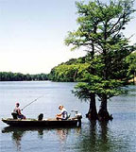**Reelfoot Lake and the Reelfoot Lake State Park**
* are only 20-30 miles from almost any point in the county. The lake is widely known for its fishing, hunting, and water sports. The American Bald Eagle winters at Reelfoot, and eagle tours sponsored by the Tennessee Department of Wildlife Resources are available.
* [*www.reelfoottourism.com*](http://www.reelfoottourism.com)
* **Kentucky Lake and the** [***Land Between the Lakes***](http://www.lbl.org) are also widely known for their recreational facilities. They are located one hour from Obion County. [*www.lbl.org*](http://www.lbl.org)

Eagle Watching

Reelfoot Lake is the home of one of the largest wintering populations of eagles in the country. From January to March, the number of bald eagles spending their winter at the lake ranges from 100-200 birds.  These majestic birds can be viewed on land or by boat. However, the most popular way to observe and learn about the eagles is through guided tours. All tours are lead by state park rangers and naturalists, who provide plenty of eagle information along the way. For more information, please visit Reelfoot Outdoors, [www.reelfoot.com/eagles.htm](http://www.reelfoot.com/eagles.htm) or Reelfoot Lake Tourism Council <http://www.reelfoottourism.com/birding.htm>.

Fishing

|  |  |
| --- | --- |
| **Type** | **Season** |
| Bass | March, April, May, June, July, September, October, November |
| Bluegill | April, May, June, July, October |
| Catfish | June, July |
| Crappie | February, March, April, May, September, October, November |

**\*Guides available. For more information contact the Reelfoot Tourism Council** [www.reelfoottourism.com](http://www.reelfoottourism.com)

**\*\*Crappie tournament in March and Catfish Tournament in July.**

**\*\*\*For fishing guidelines, visit Tennessee’s Fishing Page.** [www.state.tn.us/twra/fish/fishmain.html](http://www.state.tn.us/twra/fish/fishmain.html)

**Hunting Seasons**

|  |  |
| --- | --- |
| **Type** | **Season** |
| Deer | January, September, October, November, December |
| Dove | September, October, December |
| Duck | November, December, January |
| Goose | December, January, February |
| Rabbit | November, December, January, February |
| Raccoon | September, October, November, December, January, February |
| Squirrel | September, October, November, December, January, February |

Restaurants

Fast Food Restaurants

Arby’s (800) 599-2729

Burger King (901) 884-0107

Hardees (731) 885-2898

Zaxby’s (731) 885-5200

McDonalds (731) 885-2352

Sonic (731) 885-6912

Subway (731) 885-9440

Taco Bell (731) 885-7570

Wendy’s (731) 885-3823

### 

Chain and Local Restaurants

**Applebee’s Restaurant** (731) 886-0085 Family Dining

**\*Autry’s Kitchen** (731) 536-4736 Family Dining

**\*Bad Bob’s BBQ** (731) 886-0026 Barbeque, Catering

**\*Blue Bank Dining Room** (887) 258-3226 Family Dining

**\*Charlie T’s Café** (731) 885-8292 Café

**\*Corner BBQ** (731) 885-9924 Barbeque, Catering

**Dominos Pizza** (731) 885-8866 Delivery & Carry-Out Pizza

**Don Sol Mexican Grill** (731) 599-1515 Mexican Family Dining

**Huddle House** (731) 884-2833 Breakfast Family Dining

**\*Moustos** (731) 885-4480 Italian Family Dining

**\*Los Portales** (731) 885-6286 Mexican Family Dining

**\*Oya House** (731) 886-8688 Chinese Buffett

**\*Patio Grill** (731) 885-2355 Mexican Family Dining

**\*Penny Hill Shoppe** (731) 884-2184 Subs, Gyros, Salads

**Pizza Hut (**731) 885-1024 Pizza Buffet

**\*PV’s Hut** (731) 885-5737 Family Dining

**Ryan’s Steakhouse** (731) 885-0012 Family Buffet

**\*Cottonwood Harvest Grill** (731) 624-0045 Chicken, Steak, Seafood

**\*Scott’s Grill (**731) 599-1240 Faming Dining, Catering

**\*Snappy Tomato Pizza** (731) 885-7627 Pizza Buffet

**Yamato** (731) 886-1118 Japanese Steakhouse

*Indicates locally owned

*\*\*Union City has Liquor by the Drink.*

*\*\*Additional restaurants are listed at* [*http://www.yellowpages.com*](http://www.yellowpages.com)*.*

Facilities

Meeting Facilities

|  |  |  |
| --- | --- | --- |
| **Facility** | **Type/Capacity** | **Contact** |
| Commercial Bank & Trust ([www.cbtcnet.com](http://www.cbtcnet.com)) | Bank – 20 | 731 884-4255 |
| First Citizens National Bank ([*www.firstcitizens-bank.com*](http://www.firstcitizens-bank.com)) | Bank – 60 | 731 885-2300 |
| Simmons Bank ([*www.simmonsbank.com*](http://www.simmonsbank.com)*)* | Bank - 60 | 731 885-7090 |
| Los Portales | Restaurant – 100 | 731 885-6286 |
| Hospitality House ([*http://www.uchospitalityhouse.com*](http://www.uchospitalityhouse.com)) | Conference Center - 100 | 731 885-6610 |
| Quality Inn | Conference Center - 250 | 731 885-8850 |
| Obion County Industrial Training Center | Educational Facility - 40 | 731 884-0171 |
| Obion County Public Library ( *www.oclibrary.org)* | Educational Facility - 100 | 731 885-7000 |
| Ryan’s Steakhouse ([*www.ryans.com*](http://www.ryans.com)*)* | Restaurant – 80 | 731 886-0012 |
| Snappy Tomato Pizza ([*www.snappytomato.com*](http://www.snappytomato.com)*)* | Restaurant – 20 | 731 885-7627 |
| Sassafraz ([*www.sassafraz.com*](http://www.sassafraz.com)*)* | Restaurant - 50 | 731 884-1877 |
| The Venue at Center Point | Event Venue - 250 | 615 866-7666 |

**Union City Hotels**

Country Hearth Inn (731) 885-7774

Quality Inn (731) 885-8850

Hospitality House (731) 886-6610 [*www.uchospitalityhouse.com*](http://www.uchospitalityhouse.com)

Magnum Inn (731) 885-4444

Mainstay Suites/Sleep Inn (731) 599-7272

Holiday Inn Express (731) 599-7272

**Reelfoot Lake Lodging**

**Reelfoot Lake State Park**

2595 State Rt. 21 East

Tiptonville, TN 38079

731-253-9652

731-253-8003

[james.cox@tn.gov](mailto:james.cox@tn.gov)

<http://tn.gov/environment/parks/reelfootlake/>

**Sportsman’s Resort North**

2540 State Rt. 213

Tiptonville, TN 38079

731-253-6581

731-253-8543-Fax

[www.reelfootlake.com](http://www.reelfootlake.com)

[sportsmansresort@reelfootlake.com](mailto:sportsmansresort@reelfootlake.com)

**Blue Basin Cove**

100 Blue Basin Rd.

Tiptonville, TN 38079

731-253-9064

[jaybird@bluebasin.com](mailto:jaybird@bluebasin.com)

[www.bluebasin.com](http://www.bluebasin.com)

**Gray’s Camp**

40 Gray’s Camp Lane

Tiptonville, TN 38079

731-253-7813

731-253-6389-Fax

[www.reelfoot.com/grayscamp](http://www.reelfoot.com/grayscamp)

**Sportsman’s Resort South**

2540 State Rt. 213

Tiptonville, TN 38079

731-253-6581

[www.reelfootlake.com](http://www.reelfootlake.com)

[sportsmansresort@reelfootlake.com](mailto:sportsmansresort@reelfootlake.com)

**Reelfoot Lake Inn**

1520 State Rt. 21 East

Tiptonville, TN 38079

731-253-6845

731-253-3444-Fax

[ReelfootLakeInn@gmail.com](mailto:ReelfootLakeInn@gmail.com)

[www.ReelfootLakeInnMotel.com](http://www.ReelfootLakeInnMotel.com)

**Magnolia Beach RV Park**

3060 State Rt. 21 E.

Tiptonville, TN 38079

731-253-8777

731-589-1605

**Boyette’s Resort**

30 Boyette Rd.

Tiptonville, TN 38079

888-465-6523

[boyettesresort@lakereelfoot.net](mailto:boyettesresort@lakereelfoot.net)

[www.lakereelfoot.net](http://www.lakereelfoot.net)

[www.reelfootlaketenn.com](http://www.reelfootlaketenn.com)

**Cypress Point Resort**

3535 State Rt. 21 East

Tiptonville, TN 38079

731-253-6654; 731-253-6659

731-253-2099-Fax 800-394-1886

[cypressp@usit.net](mailto:cypressp@usit.net)

[www.cypresspointresort.com](http://www.cypresspointresort.com)

**BlueBank Resort, Marina, Restaurant & Gift Shop**

813 Lake Drive

Hornbeak, TN 38079

877-258-3226

[www.bluebankresort.com](http://www.bluebankresort.com)

[fish@bluebankresort.com](mailto:fish@bluebankresort.com)

**Acorn Point Lodge**

1685 Lake Drive

Hornbeak, TN. 38232

731-538-9800

731-538-9007-Fax

[www.acornpointlodge.com](http://www.acornpointlodge.com)

[info@acornpointlodge.com](mailto:info@acornpointlodge.com)

**Eagle Nest Resort**

6258 W. Highway 22

Hornbeak, TN 38232

731-538-2143

1-877-eagle-01

[www.eaglenestresort.com](http://www.eaglenestresort.com)

[info@eaglenestresort.com](mailto:info@eaglenestresort.com)

**Reelfoot Outdoors, LLC**

3330 State Route 21 E.

Tiptonville, TN 38079

731-253-3203

[www.reelfoot-outdoors.com](http://www.reelfoot-outdoors.com)

[reelfootoutdoors@att.net](mailto:reelfootoutdoors@att.net)

**Dragon Fly Inn Bed & Breakfast**

365 Sunkist Beach Rd.

Tiptonville, TN. 38079

731-253-0206; 731-442-0750

[maryann@dragonflyinnreelfootlake.com](mailto:maryann@dragonflyinnreelfootlake.com)

[www.dragonflyinnreelfootlake.com](http://www.dragonflyinnreelfootlake.com)

**Obion County, Tennessee - Clubs & Organizations**

**American Cancer Society**

2935 U.S. Hwy 45 Bypass

Jackson, TN 38305

(800) ACS-2345

[megan.fuller@cancer.org](mailto:megan.fuller@cancer.org)

**American Heart Association**

11 Orleans, Memphis, TN

Memphis, TN 38103

(800) 242-8721

**American Red Cross**

(731) 286-4740

(731) 676-0405

**Better Business Bureau**

1-800-222-8754

**Beulah Baptist Association**

Cynthia Norman

2126 West Reelfoot Avenue

Union City, TN 38261

(731) 885-2151

**Boys and Girls Clubs**

**Of Northwest TN**

1015 E. College St.

Union City, TN 38261

(731) 885-0883

**The Bridge**

[www.thebridgewesttn.org](http://www.thebridgewesttn.org)

**Chimes for Charity**

P.O. Box 661

Union City, TN 38281

(731) 599-4542

**Child Support Services**

(731) 886-4520

**Civitan Club**

P.O. Box 592

Union City, TN 38281

(731) 885-8641

**Community Concerts**

Mike Cox

(731) 536-4569

[www.communityconcertuc.org](http://www.communityconcertuc.org)

**Crime Stoppers of OC**

Union City, TN 38281

(731) 885-1515

**Genealogy Society**

Martha Clendenin

2211 Wedgewood Drive

Union City, TN 38261

(731) 885-2322

**Helping Hand Ministry, Inc**.

430 North Miles Avenue

Union City, TN 38261

(731) 885-3924

Open Mon.-Fri.

helping@bellsouth.net

**Union City Jaycees**

P.O. Box 71

Union City, TN 38281

**Union City J’Cettes**

P.O. Box 1415

Union City, TN 38281

**Kiwanis Club**

P.O. Box 521

Union City, TN 38281

**Lions Club**

Regina Turner, Secretary

P.O. Box 1216

Union City, TN 38281

(731) 885-2934

**Lions Club** (All OC except UC)

Wanda Forrester

(731) 536-4686

**Main Street Union City**

Phyllis Rauchle, Exec. Director

P.O. Box 382

Union City, TN 38281

(731) 885-8330

**Masonic Hall**

Ray Covey 885-3943 or 885-7185

Fred Goddard 885-5924

112 ½ West Church Street

Union City, TN 38261

**Masquerade Theater**

Todd Little

(731) 281-1213

(731) 796-6083

P.O. Box 1414

Union City, TN 38281

[masqueradeticketsuc@gmail.com](mailto:masqueradeticketsuc@gmail.com)

**Northwest Tennessee Disaster Services**

Rob Adcock CEO   
PO Box 1458   
Union City, TN  38281   
(731) 592-3947   
[support@togetherforall.org](mailto:support@togetherforall.org)   
[www.togetherforall.org](http://www.togetherforall.org)

**Obion County Arts Council**

Linda Hamblen

(731) 885-4695

**Eddie Cox Senior Citizens Center**

Depot Street

Union City, TN 38261

(731) 885-1246

**OCUC Backpack Program**

Kristen Miles (731) 885-1632 ext. 3011

Chastity Homra (731) 885-7171

**Obion County Fair**

(731) 885-5361

**Obion Co Habitat for Humanity**

885-7126 (*Wednesdays Only)*

**Obion County Historical Society**

P.O. Box 241

Union City, TN 38281

**Obion Co. Junior Auxiliary**

P.O. Box 853

Union City, TN 38281

**Obion County Ministerial Association**

Crosswind Baptist Church

Rev. Jeremy Powell

(731) 463-3388

4440 Barham Rd.

Union City, TN 38261

**Obion County Museum**

1004 Edwards Street

Union City, TN 38261

Larry Mink (731) 885-1962

**Obion County Reading Railroad**

*Imagination Library*

(731) 885-7000

Kim Taylor

(731) 796-0334

**Obion County Walk of Hope**

Lorraine Gossett (731) 884-0110

(731) 446-6866

Kim Bruer (731) 796-1536

**Promethean Foundation**

206 East Reelfoot Ave. Suite 23

Union City, TN 38261

(731) 884-0088

[**www.unioncityrotary.org/serviceProjects/promethean.asp**](http://www.unioncityrotary.org/serviceProjects/promethean.asp)

**Psalms 4:8 Foundation**

989 N Old Troy Road

Union City, TN 38261

(731) 446-6347

**Reelfoot Rural Ministries**

6923 Minnick Elbridge Rd  
Obion, TN 38240-3093  
(731) 538-9970

[www.reelfootruralministries.org](http://www.reelfootruralministries.org)

**Rotary Club of Union City**

Al Creswell

Union City, TN 38281

(731) 885-3661

**Trudy’s Kids Cafè**

306 First Street

Union City 38261

(731) 599-9936

**Union City Animal Shelter**

(731) 885-1341

**Union City Parks and Rec**

(731) 885-0354

**United Way of Obion County**

PO Box 484

Union City, TN 38281

(731) 446-2891

**UT – College of Dentistry**

201 W Main Street

Union City, TN 38261

(731) 884-0860

**Veterans of Foreign War -** Post 4862

P.O. Box 206

Union City, TN 38281

(731) 885-1502

**Westover Center for the Arts**

West Florida Avenue

Union City, TN 38261

Emily Elliston (731) 571-2216; 885-5837

[etephoto@bellsouth.net](mailto:etephoto@bellsouth.net)

Brought to you by:



Over the past several years there have been two chartered organizations operating within Obion County with the responsibility of generating new growth in the areas of Tourism, Housing, Commercial, and Industrial Development (The Obion County Chamber of Commerce and the Obion County Industrial Development Corporation). In many instances these agencies encountered duplication in both program delivery and expenditure. In an effort to improve efficiency in programmatic and budgetary areas, in early 2004, the two agencies formed the *"Obion County Joint Economic Development Council"* (JEDC)